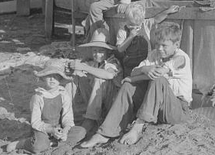
The Great Depression brought many economic problems to South Carolina in the 1930s. Farm prices were low and many factories, banks, and businesses closed.

Instructions: Use the information in the links below to complete the activities.

Part I: Click here for Library of Congress: Great Depression Photos.
In the “Search this Collection” box, type “South Carolina” and click GO.
Children of a sharecropper, Manning, SC, 1939.
Source: Library of Congress, Prints and Photographics Division, FSA-OWI Collection, fsa 8a40753
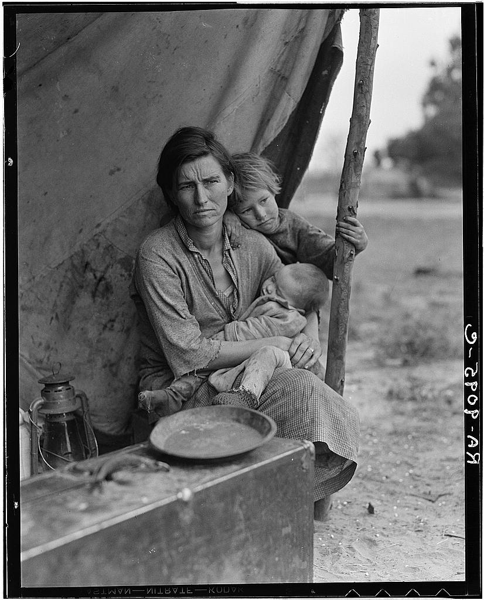

Click the Grid link. When you see an image that you are interested in, click it. Return to the grid when you are done. Click the Next Page link, as needed, to view more pictures of our state during the Great Depression.

To enlarge the pictures, click the small version of the picture, and click it again.

Your task: Imagine that you work for a book publisher. You must choose one or two pictures of the best pictures from this collection to include in a chapter about New Deal projects in South Carolina during the Great Depression.
Migrant farmwoman, 32, with seven hungry children, 1936.
Source: Library of Congress, Prints and Photographs Division, FSA-OWI Collection, fsa 8B29525

When you have made your choice, print the picture(s). Staple the printed picture(s) to this page.

Write a paragraph to explain why you chose the photo(s). What qualities do they represent about the topic? What facts would viewers gain? What emotions might viewers have when looking at the photo(s)?

________________________________________________________________________

________________________________________________________________________

________________________________________________________________________

Part II: Read through the websites below to find facts about the CCC (Civilian Conservation Corps) in South Carolina. This program was designed to give unemployed young men a job during the Great Depression.

The CCC in South Carolina General Article on CCC

- Which president created the CCC? ____________________

- What was the pay for CCC workers, and how was the salary used? _________________________________________________________

- List four types of CCC work. __________________________________________________________________

__________________________________________________________________

- Why was the CCC discontinued? __________________________________________________________________

- What are two parks in South Carolina built by the CCC?

__________________________________________________________________
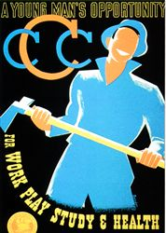
Source: National Archives

kkk
Part III: Study the poster at right.

- What do you think was the purpose of this 1930s CCC poster? How was the poster supposed to get a viewer’s attention? _________________________________________

_________________________________________

- According to the poster, what would young men in the CCC get to have? _________________________________________

_________________________________________

